**Answer 1:**

**Home page**

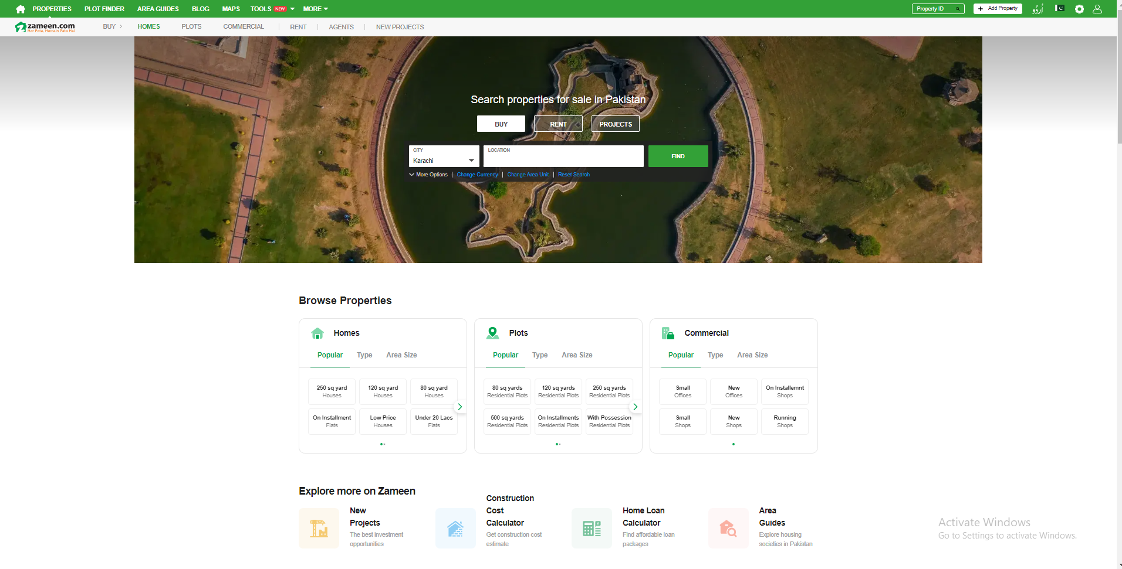

**Signin/Login**

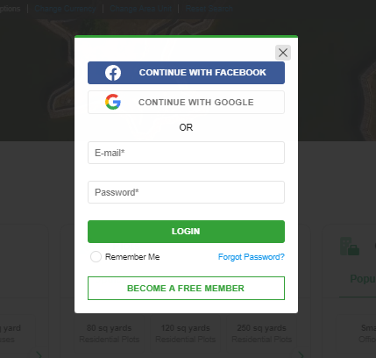

**Search Properties**

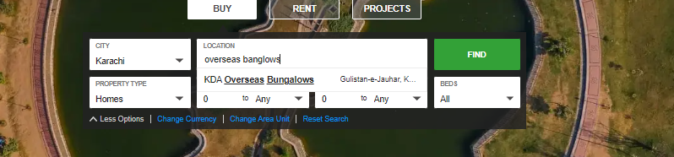

**Search Results**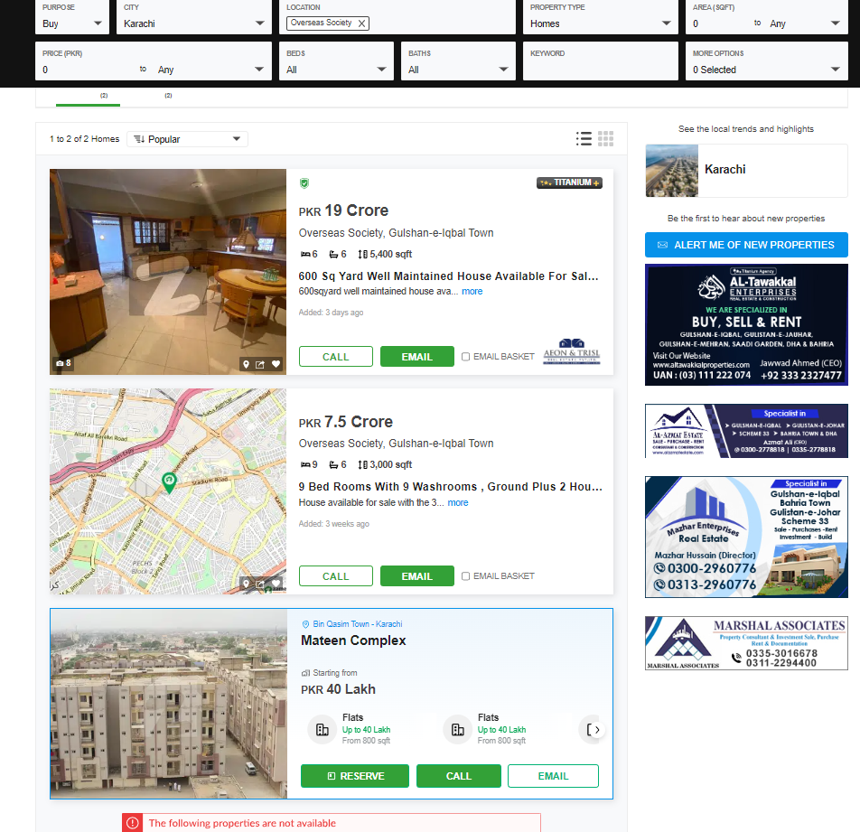

**Property Display page**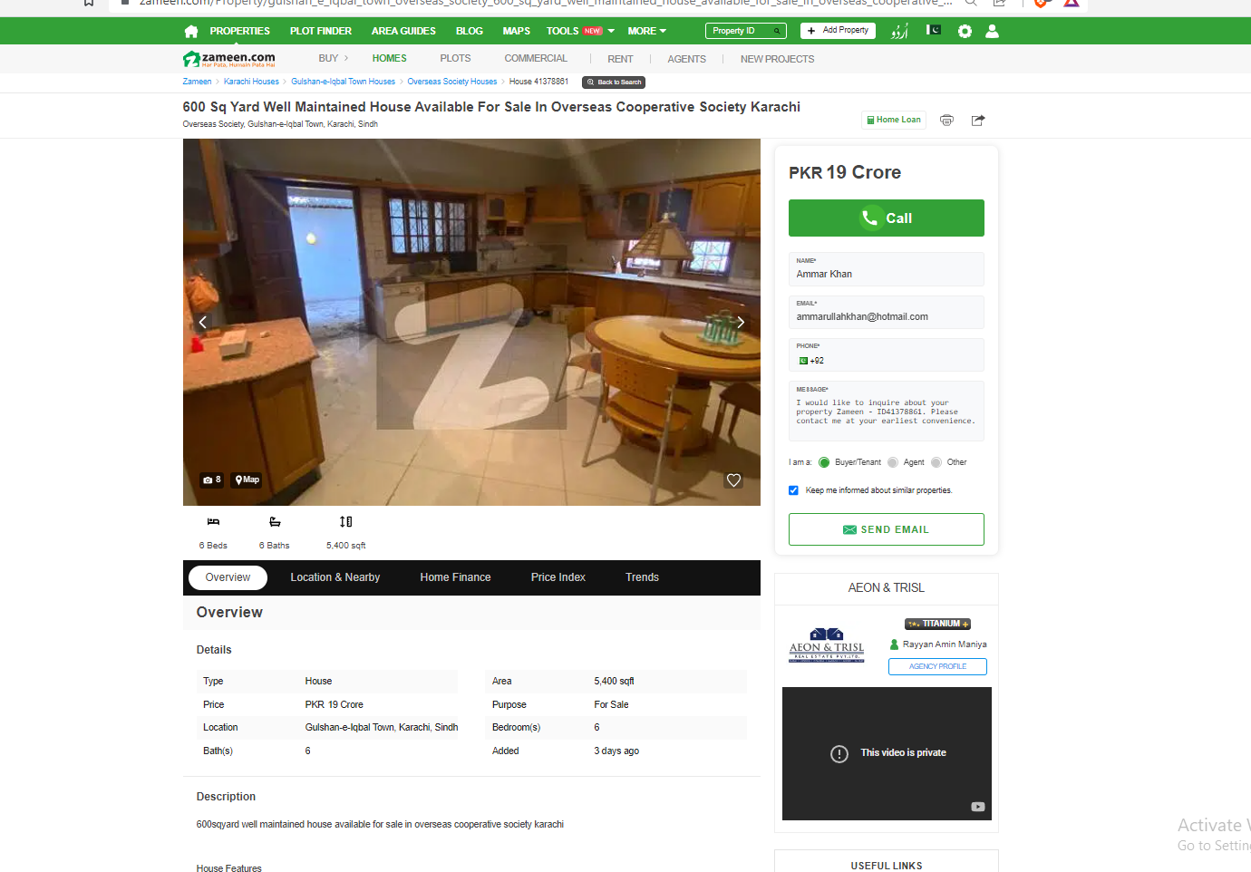

**Conversion Negotiation**

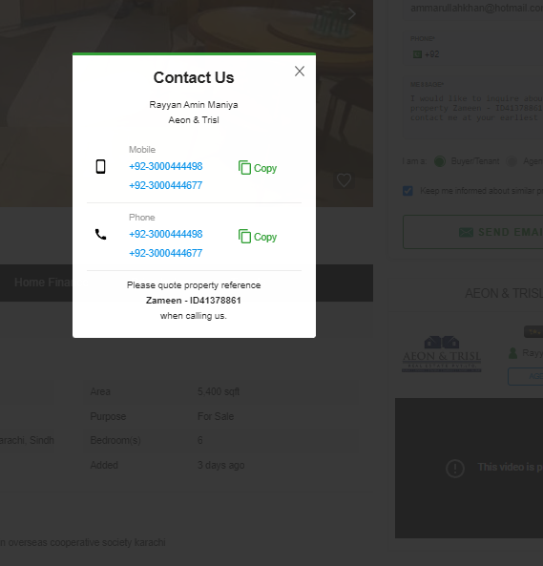

**Adding our own Property**

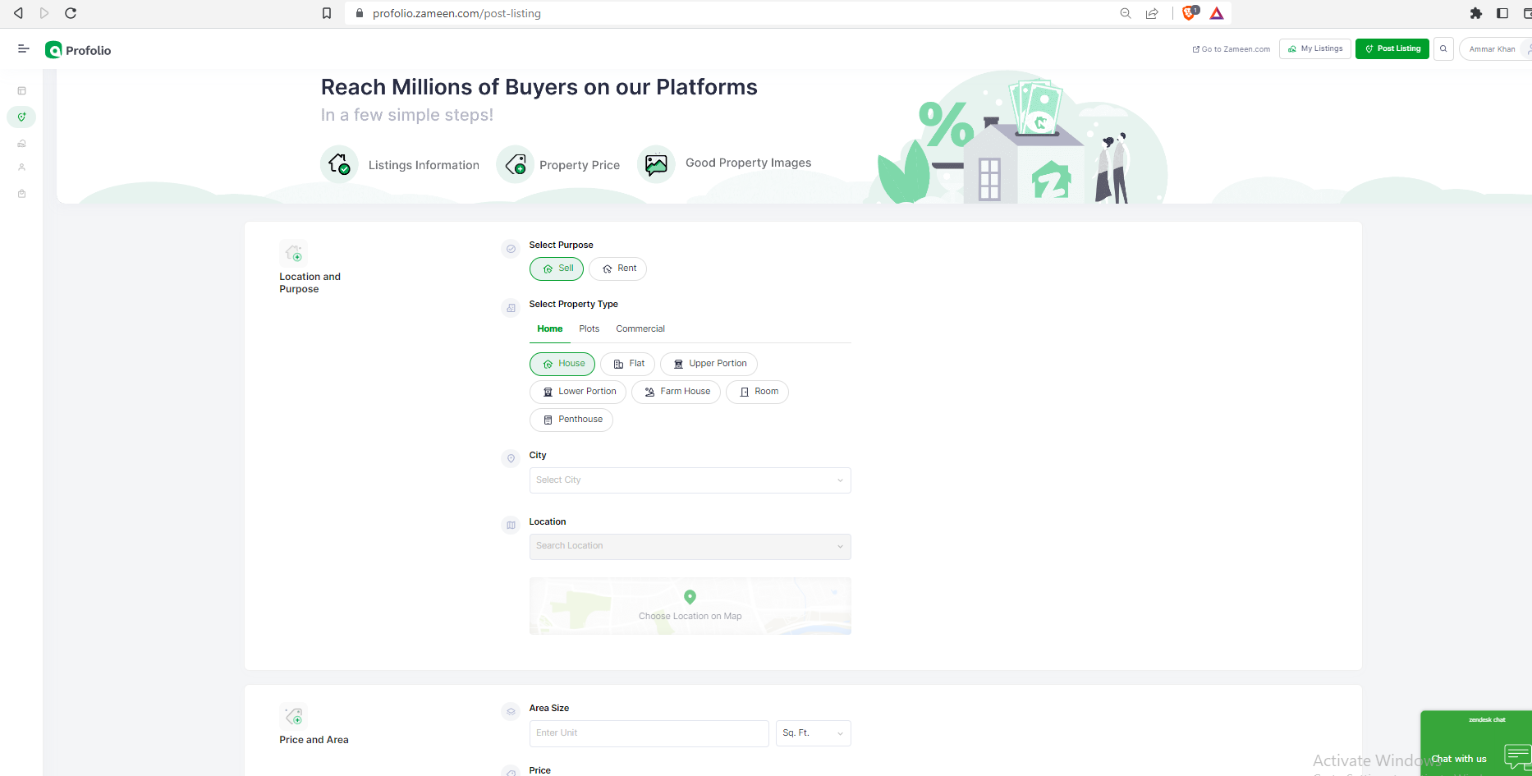

ANSWER_2:

**State Transition Diagram:**

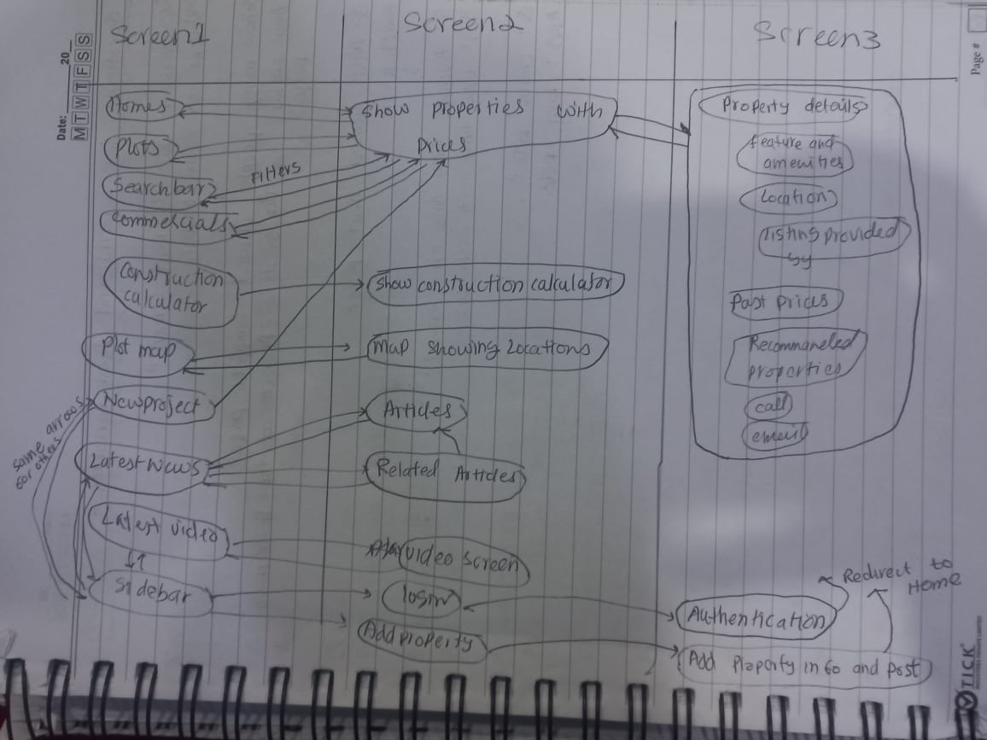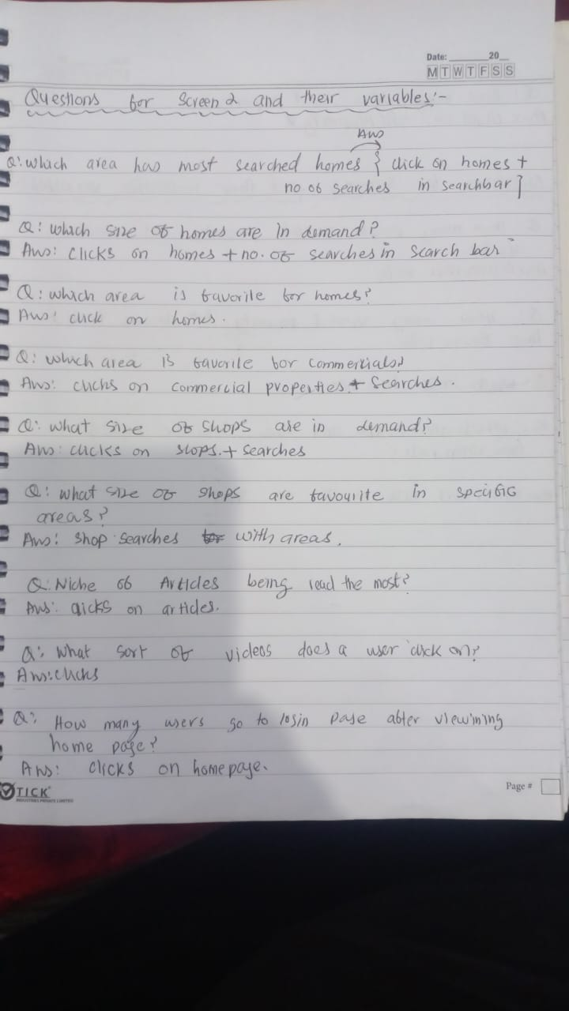

**Answer 4 (Was done after Q3 but I have to adjust it here due to word Issues):**

**Google Analytics:**

|  |  |  |  |
| --- | --- | --- | --- |
| Variable | Google Analytics Availability | Variable | Google Analytics Availability |
| Number of Sessions | TRUE | Does request for more info | TRUE |
| Average time of sessions | TRUE | Is satisfied with further results shown | FALSE |
| Text format feedback | FALSE | Is not satisfied with further results shown | FALSE |
| Time spent Scrolling on Recommended Property page | FALSE | Time spent registering | FALSE |
| Time spent Scrolling on Sponsored Property page | FALSE | Time spend on recommended properties | FALSE |
| Number of Clicks taken to reach target | FALSE | Time spent on searched properties | FALSE |
| Time Scrolled to reach property in recommendations | FALSE | Number of times user searches for keyword before they find their desired result | FALSE |
| Property opened on first search keyword | FALSE | Response time to sign user in | FALSE |
| Keywords taken to arrive at desired property | TRUE | Response time of server to validate credentials | FALSE |
| Count Bounces from Recommended page | TRUE | Search response time | FALSE |
| Count Bounces from Search page | TRUE | Response time of showing filtered properties | FALSE |

**ANSWER_3**

**Engagement Metrics**

Hypothesis:

* Seamless Signup and Sign in improves engagement.  
  Metric: Seamless Signup/Sign In
* Great Home page experience improves engagement

Metric: Activity span on home page spent on home page

* Smooth to register any property is proportional to engagement.  
  Metric: Property Registration
* Search results accuracy improves engagement.  
  Metric: Search results accuracy
* More Activity span on search result is directly proportional to engagement.  
  Metric: Activity span on search result.
* Bouncing back from the search result page is bad for engagement.  
  Metric: Bounce-back rate from search results.
* Conversion from platform contacting property owner.  
  Metric: Number of times user contacted property owner.
* Reliability of user on the platform.

Metric: After purchase feedback

* Zameen certifying the seller and property will improve engagement

Metric: purchase behavoir

|  |  |  |  |  |  |  |  |
| --- | --- | --- | --- | --- | --- | --- | --- |
| **Metrics** | | Variables | | | | | |
| Seamless Signup and Sign in | | Successful  Signup  Count | Not successful  Signup count | Successful Sign  in count | Not Successful  Sign in count | Successful  Signup  count |  |
| Activity span on the home page | | Average time of user on home page | Most visited part of page by capturing clicks | No of users viewing the complete page by capturing clicks in the bottom of page | No of time user clicked  On property displayed on home page |  |  |
| Seamless Property registration | | Average time took by user to register property | Number  Of successful registrations | Number of user left half in registration process | Field which is left unfilled for max number of times |  |  |
| Search Result Accuracy | | Number of times a user clicked on top three searches | Number of additional filters added by user | Number of taps it took user to reach required property | Property opened on first search keyword | Bounce Back rate from search page | Search response time |
| Activity span on search result page | | Number of scrolls in the search result page | Average time on the search result page | No times a user clicked on property displayed on | No of times a property is clicked on search page |  |  |
| After purchase behavior | | Number of good feedback | No of complaints | Number of complaints against a particular seller | Number of complaints for each category | No of problem were solved by Zameen Team |  |
| Activity span on property page | | Conversion rate | Bounce rate | Number of Complete page views |  |  |  |
| Purchase  Behavior | The conversion rate of properties  Certified by Zameen | | Zameen | Ratio of views certified to noncertified  properties |  |  |  |